Name: ___________________________________ Date: ______________________ Period: _______

**Answer Key**

**Independent Practice: Punnett Squares**

**The alleles are the same (e.g. gg, GG, BB, tt)**

Define ***homozygous*** _____________________________________________________________

**The alleles are different (e.g. Gg, Bb, Pp, Tt)**

Define ***heterozygous*** ____________________________________________________________

Circle the following genotype(s) that are **homozygous**: **BB Bb bb**

Circle the following genotype(s) that are **heterozygous**: **BB Bb bb**

**Use the information above to answer the following**

**questions and to complete the table below.**



1. What is the genotype of an animal that is

**TT**

homozygous dominant for tail length? _____

What would this animal’s phenotype be?

**Long tail**

____________________________________

2. What is the genotype of an animal that is

**Ee**

homozygous recessive for ear size? _____

What would this animal’s phenotype be?

**Large ears**

_____________________________________

**EE**

3. What is the genotype of an animal that is homozygous for large ears? _____

**Large ears**

What would this animal’s phenotype be? ________________________________

**Tt**

**Long tail**

4. What is the genotype of an animal that is heterozygous for tail length? _____

What would this animal’s phenotype be? ________________________________

**Bb**

5. What is the genotype of an animal that is heterozygous for eye color? _____

**Green eyes**

What would this animal’s phenotype be? ________________________________

**Complete the table below for the rest of these genotype/phenotype combinations.**

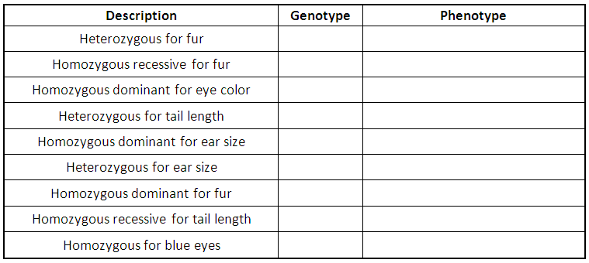

**gg striped gray fur**

**Gg solid gray fur**

**BB green eyes**

**Tt long tail**

**EE large ears**

**Ee large ears**

**GG solid gray fur**

**tt short tail**

**bb blue eyes**

**Complete the following Punnett squares and answer the questions go with each pair.**

**Use the table of information below to answer questions 1-4.**

**G g**

**G GG Gg**

**g Gg gg**

1. **Gg (**♂**) x Gg (**♀**)**

What is the ratio of green feathers to yellow feathers?

_______________________

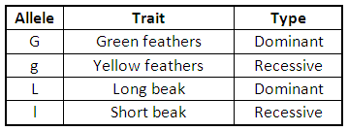

**3:1**

**l l**

**L Ll Ll**

**l ll ll**

**G G**

**G GG GG**

**g Gg Gg**

**L l**

**L LL Ll**

**l Ll ll**

4. **Ll (**♂**) x Ll (**♀**)**

What percentage of offspring

will have long beaks?

_______________________

2. **GG (**♂**) x Gg (**♀**)**

What percentage of offspring will be

homozygous recessive?

_______________________

3. **A male which has a short beak is crossed with a female that is heterozygous for beak length.** What percentage of offspring will have short

beaks?

_______________________

**75%**

**0%**

**50%**

**p p**

**P Pp Pp**

**p pp pp**

**S s**

**s Ss ss**

**s Ss ss**

6. **pp (**♂**) x Pp (**♀**)**

What percentage of offspring

will have white flowers?

_______________________

**Use this information for questions 5-9 on this page.**

5. **Ss (**♂**) x ss (**♀**)**

What will be the ratio of smooth peas to wrinkled peas?

_______________________



**50%**

**1:1**

**P P**

**p Pp Pp**

**p Pp Pp**

**S s**

**S SS Ss**

**s Ss ss**

**t t**

**T Tt Tt**

**T Tt Tt**

7. **A plant which is short is crossed with a plant that is homozygous dominant for height.** What percentage of plants will be short?

_______________________

9. **A plant which is homozygous for purple flowers is crossed with a plant that has white flowers.** What percentage of offspring will

have purple flowers?

_______________________

8. **Two plants which are heterozygous for pea shape are crossed with each other.** What percentage of plants will have

wrinkled peas?

_______________________

**0%**

**100%**

**25%**

© Haney Science